**Vagrant**

Vagrant is a command line tool that will manage virtual Machine(VM). It will manage VM magically for us.

It is a VM automation Tool & command tool to manage VM.

VM Management Problems:

* OS Installation
* Time Consuming
* Manual setup
* Tough replication for Multi VM
* Documentation for Multi VM

**We can resolve These Problems by using Vagrant.**

Vagrant for VMs:

* We don’t need ISO image for Installation.
* We create or Setup VM’s through images (Vagrant Boxes). These are ready made images available on vagrant cloud from there vagrant will pull that image & create a VM from that.
* It’s not Installation. Its cloning & all the information can be managed through simple file (Vagrantfile).
* VM changes automatic through Vagrantfile
* VMs will be managed through Vagrant commands
* Provisioning VM/Executing commands & scripts.

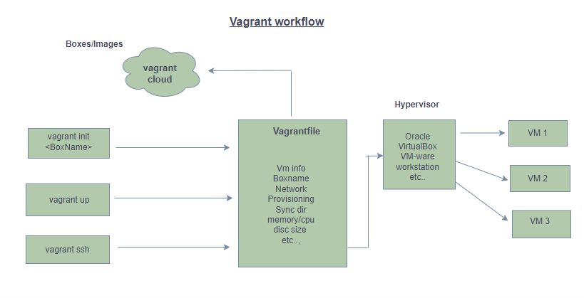

Vagrant Setup:

* VT (Virtualization Technology) Enabled in BIOS
* Vagrant Tool
* Hypervisor like oracle Virtual Box (Default).
* CLI (command Line Interface) like Git Bash, Cygwin, CMD prompt etc..

Steps to Install Vagrant

Go to Browser – Search as vagrant

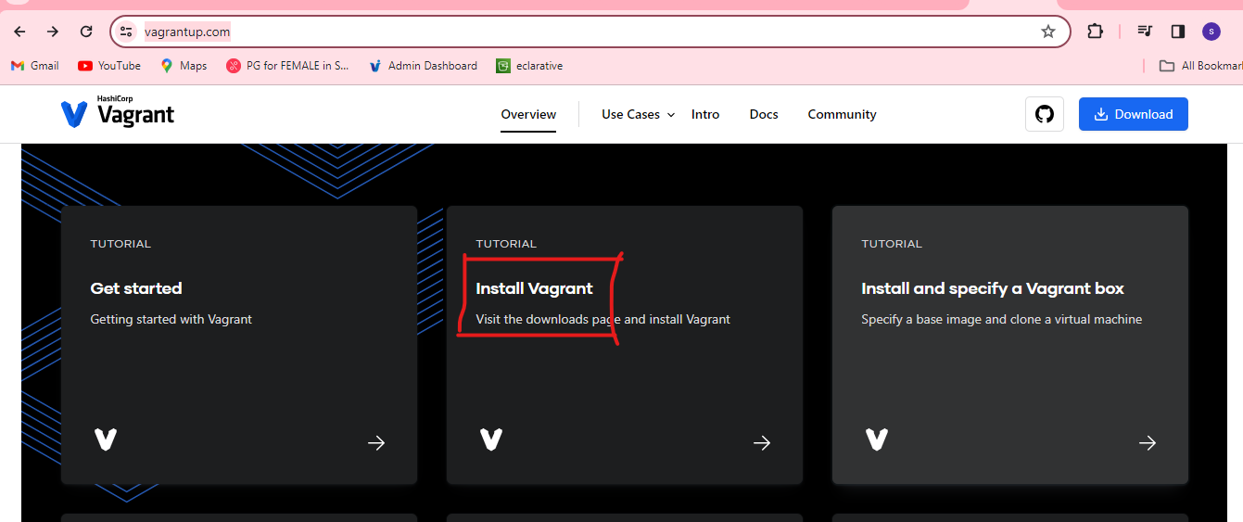

Click on Install Vagrant

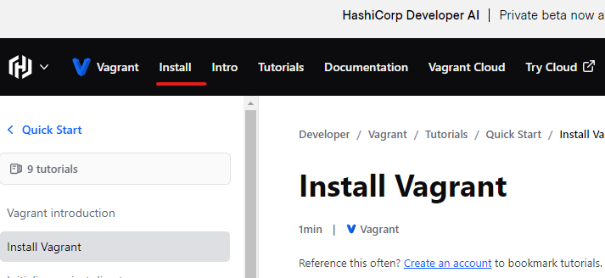

Click on Install – scroll down – select windows – AMD64- click on Download.

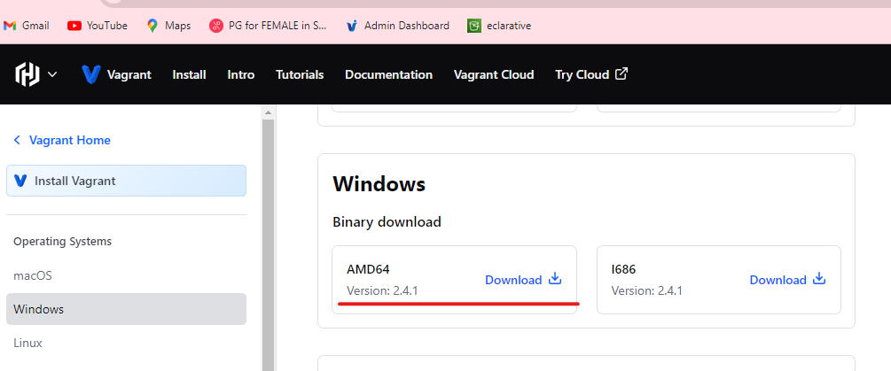  
Then It will download on local system. In local System go to Downloads



Double click on it. Go with the Default conditions. After completion system will ask restart to do the changes. So, restart the system.

Open Git Bash terminal – check your present path using the below commands.

# pwd

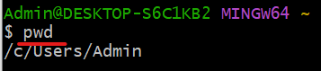

I want to use d drive. So that’s why I changed the path.

# cd /d/



Create a directory for vagrant & go inside of it.

# mkdir vagrant

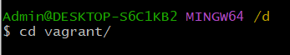

# cd vagrant

Create 2 Directories

# mkdir centos

# cd centos

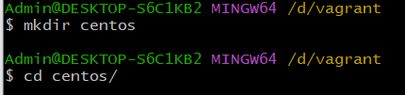

Go inside of the centos directory & execute the following commands

# cd centos

# vagrant init centos/7

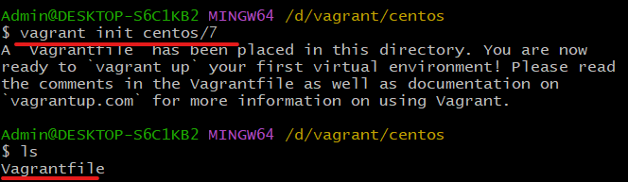

After applying this command vagrant will create Vagrantfile. Use the below command to see the content in the file.

# cat Vagrantfile

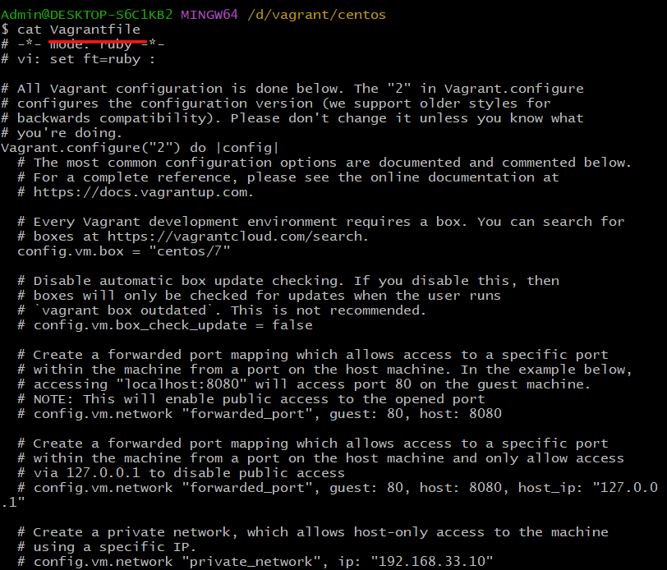

Now execute the vagrant up command. Then vangrant will create a vm. By defaultly vagrant username: vagrant

Password: vagrant

# vagrant up  
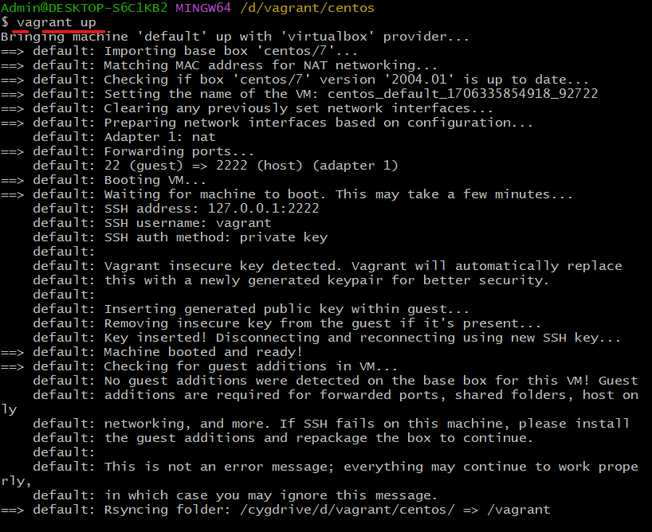

To ssh into the vm use the below command

# vagrant ssh

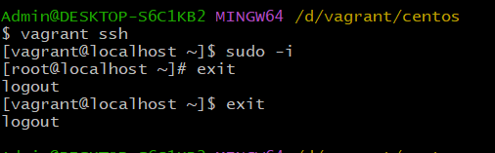

To stop the VM use the below command. Make sure to be in that particular path only

# vagrant halt

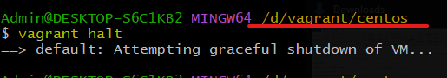

To start the vm which is in stopped state use the below command only

# vagrant up

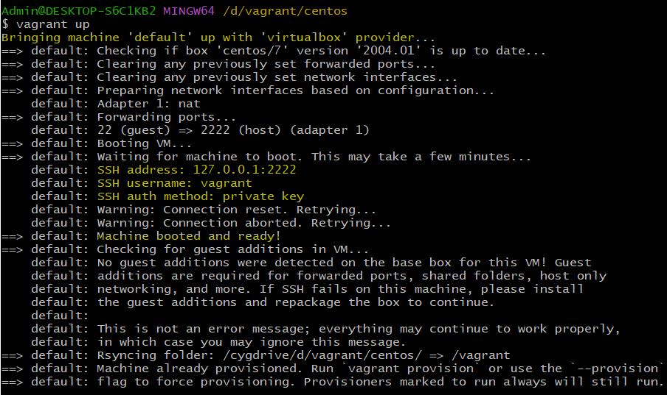

To remove or uninstall the vm use the below command. Make sure you need to be in the particular path only.

* Now create Another VM with Ubuntu OS

# mkdir Ubuntu

# cd ubuntu

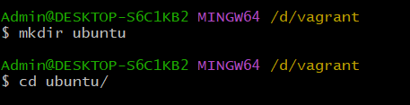  
Now search the OS Name in vagrant cloud. Now execute the below command this command will initialize the vagrant and create a Vagrantfile in which all the configuration data will be exist.

# vagrant init ubuntu/xenial64

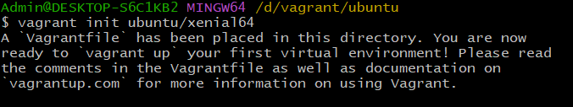

Now execute the below command it will create the Ubuntu VM for us.

# vagrant up

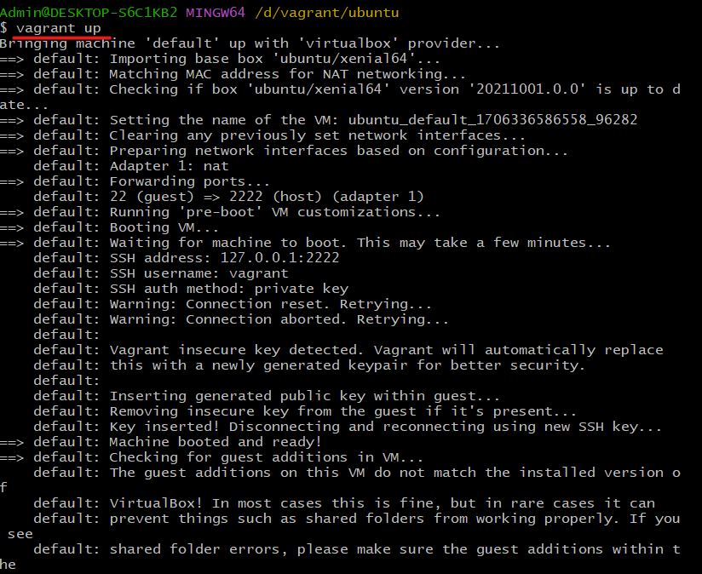

To ssh into the vm use the command. When we execute the below command we need to be in that particular path then it will search for the ssh key and try to connect to the VM.  
# vagrant ssh

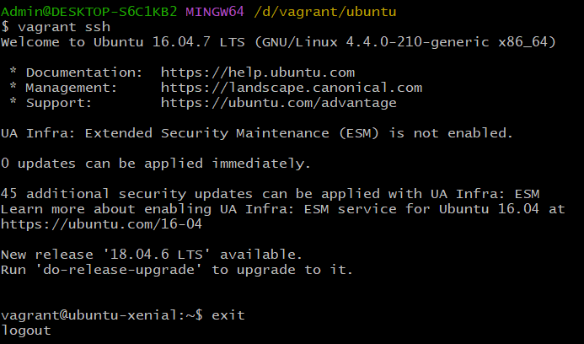

# vagrant destroy

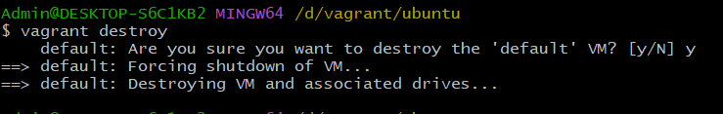

Reference:

Vagrant link: <https://developer.hashicorp.com/vagrant/install>